2018

HOOF KY, INC



Baltazar, Trisia

Barnett, Turner

Boone, Adrian

Daily, Chad

Kovacs, Mate

Morrison, Joseph

HOOF KY

Website

User Manual

A Computer Information Systems Web Development Project

**© SwiftRiver**

Trisia Baltazar

Turner Barnett

Adrian Boone

Chad Daily

Mate Kovacs

Joseph Morrison

December 2018

Contents

Introduction 3

Chapter 1: Navigation through the HOOFKY Website 4

1.1 General Navigation 4

Chapter 2: The HOOFKY Website 5

2.1 Home 5

2.2 Donate 6

2.3 Gallery 7

2.4 Location 8

2.5 About Us 9

2.6 Contact Us 10

# Introduction

**Purpose:**

The purpose of this User Manual is to help guide you through various pages of the HOOFKY website and to provide the administrator with the proper instructions for updating the website content.

**Background:**

HOOF KY is a non-profit organization that provides equine education such as riding, equine care, equine physiology and psychology, and barn management. Instructors assist students in creating a caring relationship with the horses. HOOF helps young children become stronger and independent through their summer camps. Through life struggles the children face each day, HOOF is there to help destress and break down walls children have today.

To let HOOF’s passion be known and the importance of donating, it was determined that a website with on the history of the organization, a donation page, pictures and many more would attract people of all ages to see what HOOF has to offer. It is an informative, yet simple website so that users may access information they please with no confusion.

**About the Developers:**

The developers for this project are Trisia Baltazar, Turner Barnett, Adrian Boone, Chad Daily, Mate Kovacs, and Joseph Morrison. All are enrolled in Computer Information Systems 420 Development Project during the 2018 School Year. The site has been designed by Team SwiftRiver.

**The Website:**

The organization’s website (http://hoof-ky.bss.design) consists of 6 pages.

* Home page includes static information as well as dynamic links to other websites
* Donate page contains user input boxes to donate to the organization
* Gallery page contains pictures
* Location page shows the location of HOOF KY
* About us contains information about the organization
* Contact us contains information on how to reach out to the board members of HOOF KY

# Chapter 1: Navigation through the HOOFKY Website

## General Navigation

Navigation through HOOFKY’s website does not require any special skills or specialized software. The website was developed to be accessible using any modern web browser.

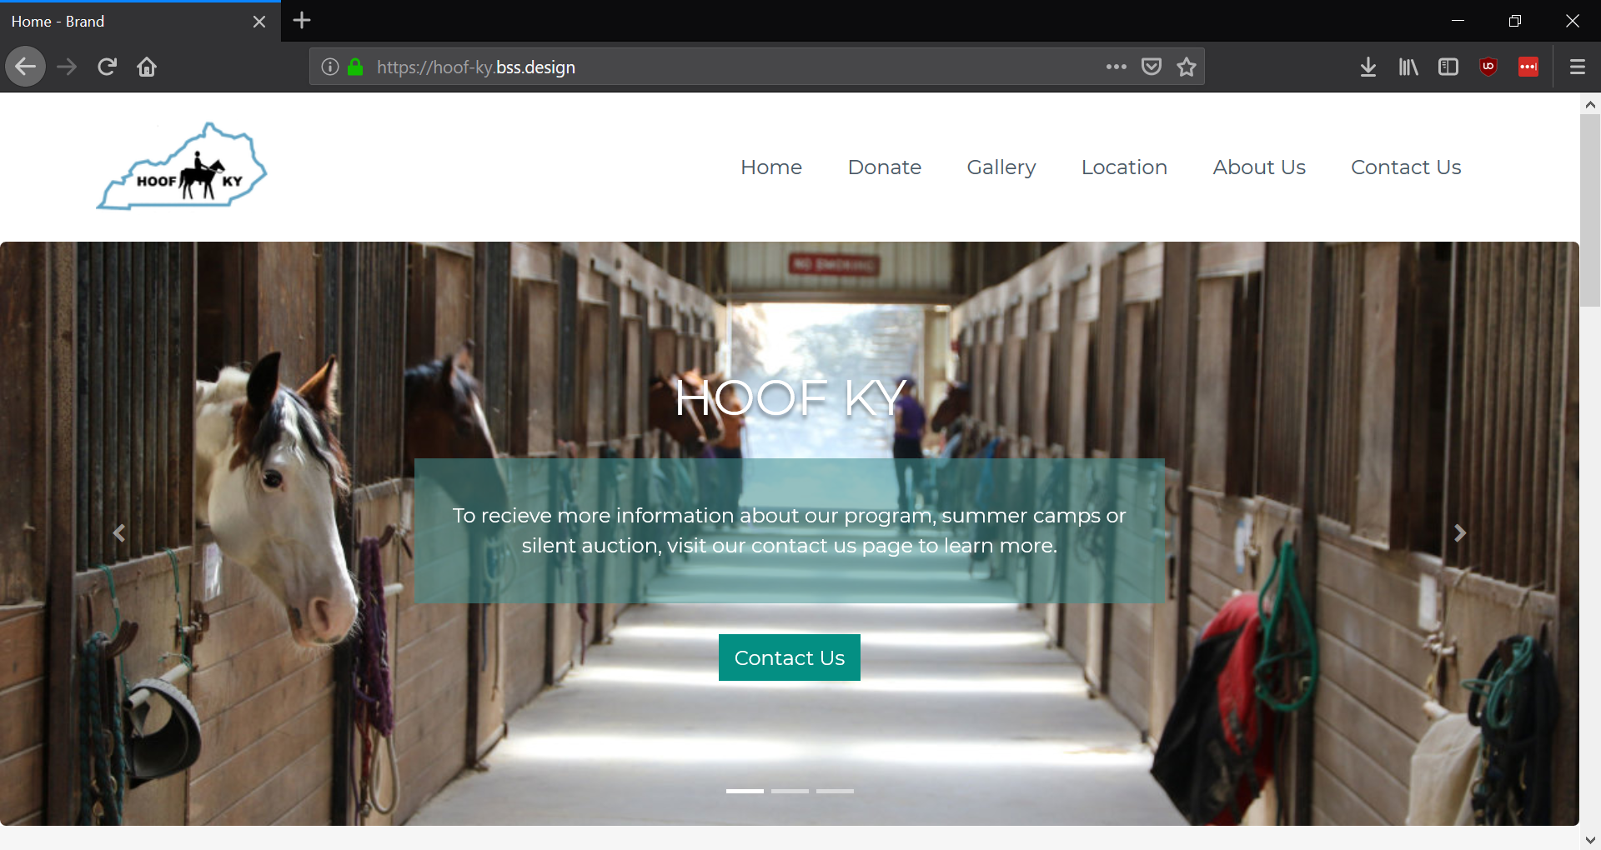

A standard Firefox browser window is shown above (displaying the HOOFKY Home Page). Explanations of the common features are as follows:

* **Back** – The back button will cycle backward to the previously viewed page.
* **Forward** - The forward button will cycle forward to the previously viewed page.
* **Refresh** – The Refresh button will fetch a fresh version of the page which you are currently looking at. This is useful in cases where the data may have been changed.
* **Address Bar** – The address bar is the location where you can type any web address that you want to view. For instance, to view the store’s website you would enter <http://hoof-ky.bss.design> and press the ENTER key. This would direct your browser to the HOOFKY website.

All pages of the website have a similar format. The left portion of each page contains the links to each web page on the web site. This allows the user to access each of the web pages without having to go back to the Home Page time after time. All links will appear underlined. Below this information, the main content of the page will appear.

# Chapter 2: The HOOFKY Website

## 2.1 Home

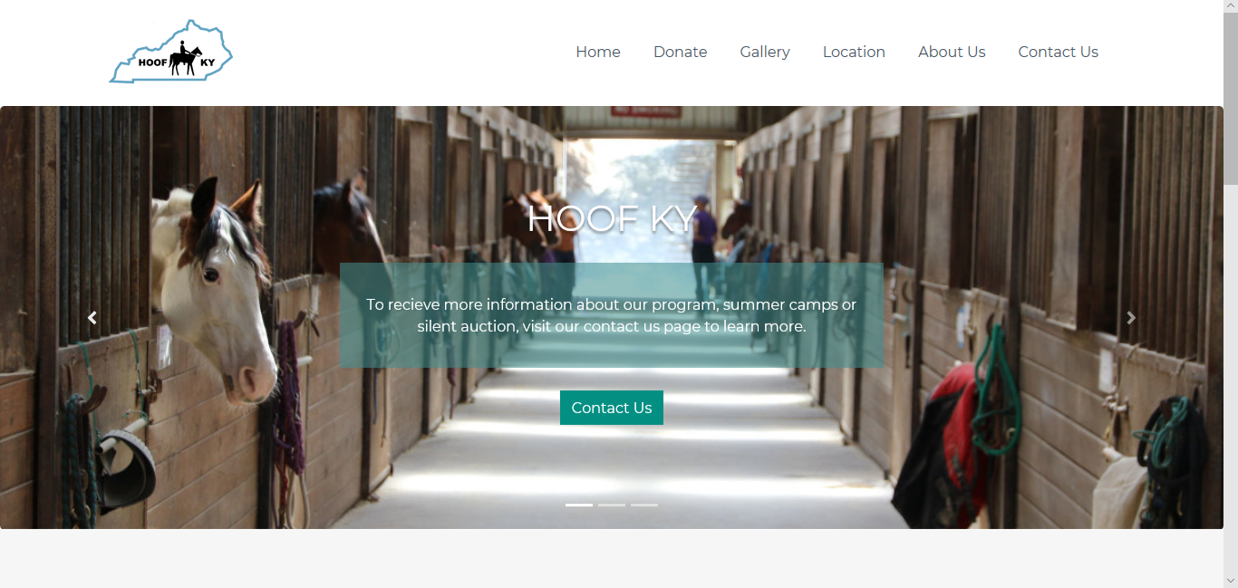

**What does this page contain?**

**The HOOF KY home page contains the following:**

Navigation Bar: This horizontal navigation bar is located on top of the home page. It connects you to different pages throughout the website. There are a total of 6 buttons on the navigation bar. The first button is the Home button which leads you to this current page. This displays an overview of what the organization is and is the first page visitors will see when accessing the site. The second button is the Donate button. It will display a page were visitors can input information and donate towards the organization. This page shows the location of HOOF KY headquarters. The third button is the Gallery page. This page shows images of the horses the camper will see in HOOF KY Summer camps. The fourth button is the Location page. The fifth button is the About Us button. This page displays company history and goals. The sixth button is the Contact Us page. This page will display how to contact HOOF through email and P.O Box. The navigation bar is on top of the page at all time and it will allow you to easily navigate to other pages without refreshing or hitting the back button. It allows ease of access at each page and allows you to explore the website in one click.

## 2.2 Donate

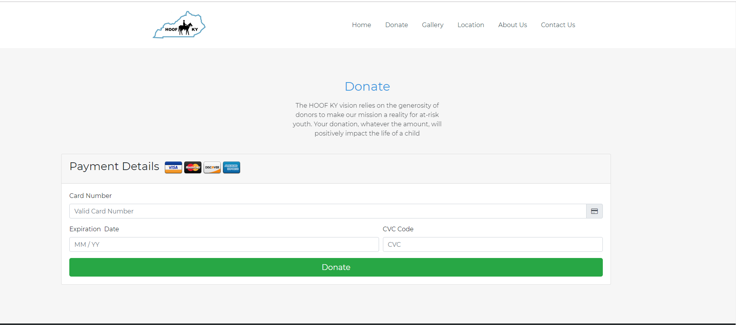

**What does this page contain?**

This page also contains the navigation bar at the top with all of the same buttons as the home page. The Donate page is a page that allows users to make donations to HOOF directly through the website instead of the old system of having to mail in donations. This page is connected to PayPal so that all of the financial information is being processed by them to alleviate the need for the website to have increased security measures to keep that information secure. The information required for a user to make a donation is the standard billing information such as Card number, expiration date, and the CVC code. At the bottom of the page is a button labeled “Donate” which when clicked will process their entered information and complete the donation process.

## 2.3 Gallery

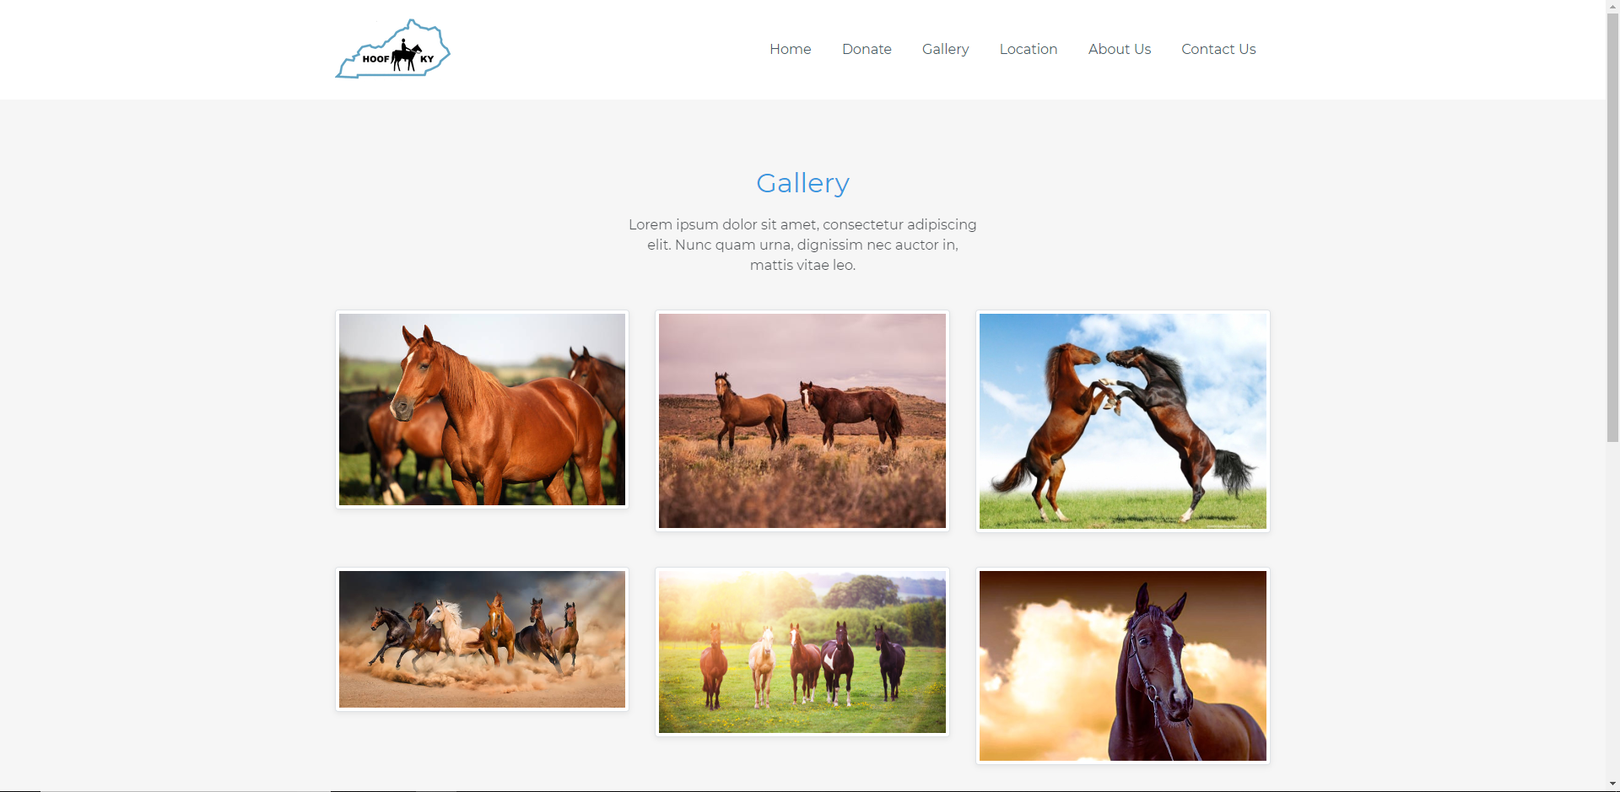

**What does this page contain?**

The Gallery page serves as a place to display any pictures that are desired. The page starts with a navigation bar that is identical to the other pages. Using this navigation bar, users can navigate to their selected page. Moving down, users will encounter a brief description of the gallery. Proceeding further, users will be able to view pictures all at once or enlarge each picture by clicking on them. If clicked, the picture will enlarge and users can either close it, or click on the left or right side of each picture to change the picture.

## 

## 2.4 Location

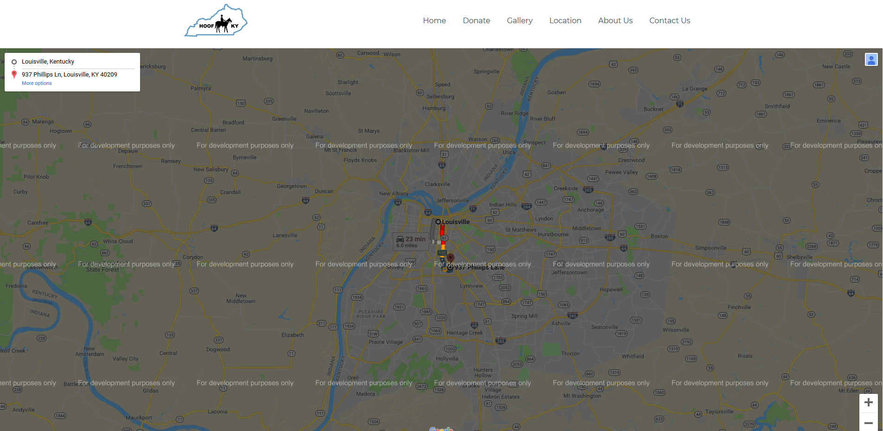

**What does this page contain?**

This page contains the navigation bar at the top of the page with the same menu structure as all the other pages in this prototype. The location page can be accessed from any other page of the website by hovering over the Location button on the navigation menu at the top of the page. The location page has an embedded and fully functional Google Maps map that can be used for finding directions to HOOF KY events. The user can use the embedded Google Maps location page by inputting their current location in the first box on the top left of the map, and their destination in the box below their current location. After the user inputs their current and desired location, Google Maps will show the fastest routes by car, bus, train, biking, and walking. The user will also have options to select to avoid highways and tolls if necessary.

## 2.5 About Us

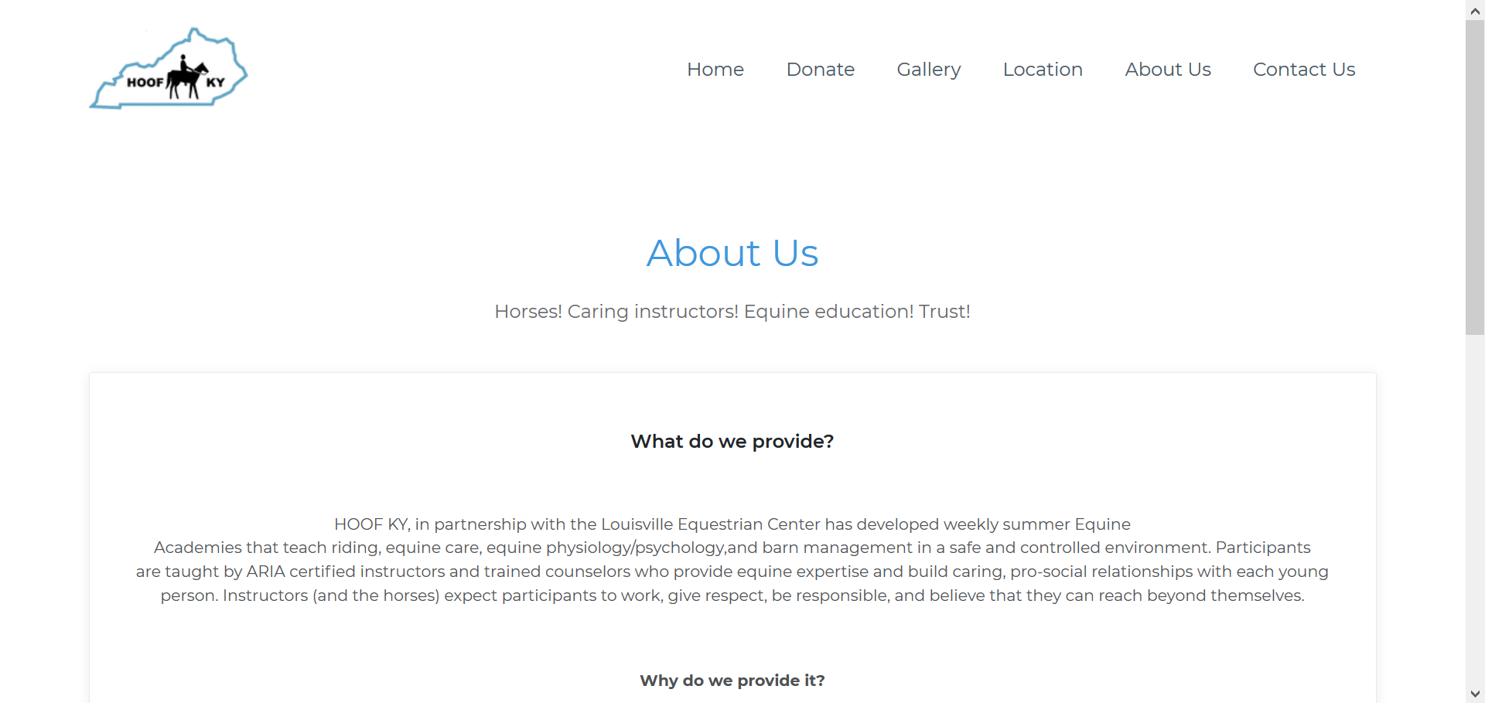

**What does this page contain?**

The About Us page contains the same navigation bar along the top as all the other pages, allowing easy access to any other part of the site. The About Us page can be accessed from anywhere else on the site by clicking on “About Us” on the navigation bar. This page contains brief, paragraph-long descriptions of what Hoof KY’s mission statement and goals are, and why they offer their therapeutic services.

## 2.6 Contact Us

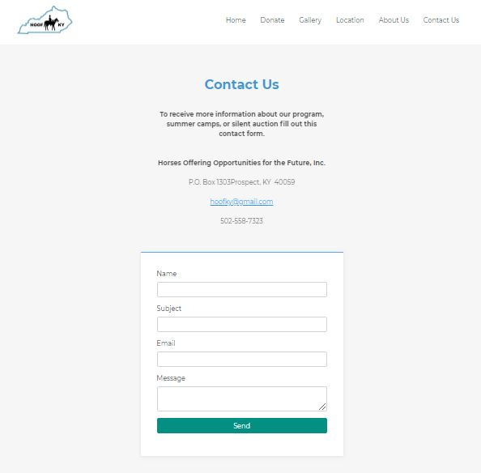

**What does this page contain?**

This page also contains the navigation bar at the top, exactly like the home page. The Contact Us page is a way for users and visitors of the website to reach out to HOOF KY for inquiries and other relevant information regarding the services provided, future events, and any questions the user might have. The page provides an address for users to mail donations. There is also a contact form for the user to fill out if they have any questions. The user will fill out the form and provide a NAME, SUBJECT, EMAIL, and MESSAGE for HOOF KY to respond to. The user will then click “SEND” to send the inquiry to HOOF KY.